How to Prepare the Manuscript for
Title
JSASS-2025-SXXX
Please fill in the 3-digit paper number provided after submission
15mm
23mm
Helvetica 12 pt
the JSASS Western Branch Conference 2025

O Ichiro Koku (□□ Univ.) and Hanako Uchu (△△ Institute)

Key Words : Society Activities, Western Branch, Paper Format

Abstract
This is the manual for how to prepare your manuscript for the Annual Meeting of Japan Society for Aeronautical and Space Science (JSASS) Western Branch. All the final drafts should be written by word processors with the format specified in this manua1. Your final paper in a PDF form must be submitted via the electronic editorial system by October 3th, 2025. Any questions regarding this manual should be addressed to the Western Branch Secretariat.

- Introduction
This is the manuscript format for JSASS Western Branch Conference 2025.

- Notices
Please prepare your manuscript following Table. 1. Please put a table caption at the top of the table with a table number, and put a figure caption at the bottom of the figure with a figure number, labels and units for axes.

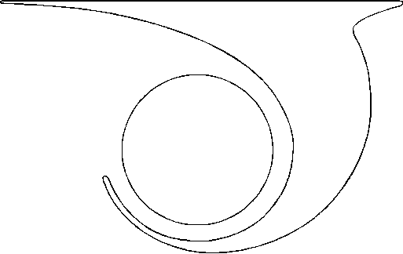
Fig.1 Figure description.

- Submission of your manuscript
Convert your manuscript to PDF file, and submit it via the electronic editorial system on JSASS Western Branch website. Number of pages has to be 8 pages or less, and PDF file size has to be smaller than 5 MB.

- Deadline for Submission
17:00, October 3th, 2025.

Table 1 Manuscript Format
Paper size | A4
Number of pages | 8 pages or less
PDF file size | Smaller than 5 MB
Margin | Left and right - 23mm，  Top and bottom – 25mm
Font | Times New Roman
Font size | 9.5-point（9- to 10- point）
Line space | 50% of the Font size
Columns | Two columns except for the paper title and abstract
Paper title | 16-point, Times New Roman
Author names | Put authors’ names with two blank lines after paper title.  Put “O” before presenter.
Affiliation | Put your affiliation after author name with parenthesis
Key words | Put 3 to 5 key words two blank lines after authors names.
Abstract | Write abstract with one blank line after key words.

*Please note that the copyright of the submitted papers is held by the Japan Society for Aeronautical and Space Sciences.

